A122-Eur-Greece-Attic-Kylix-inscribed-ca 450 BCE

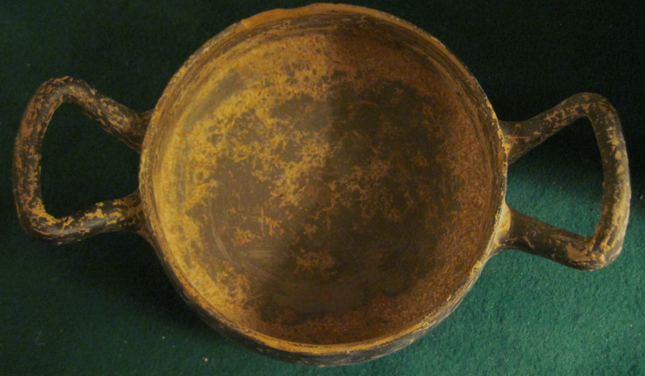

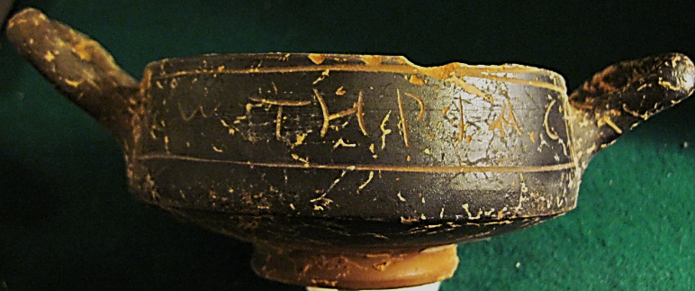

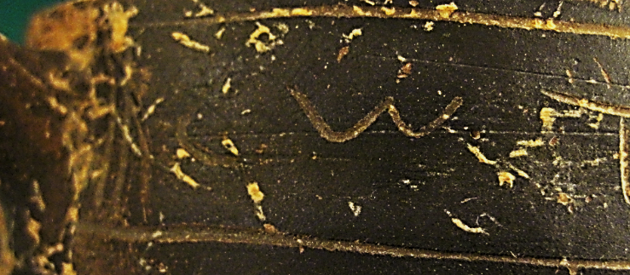 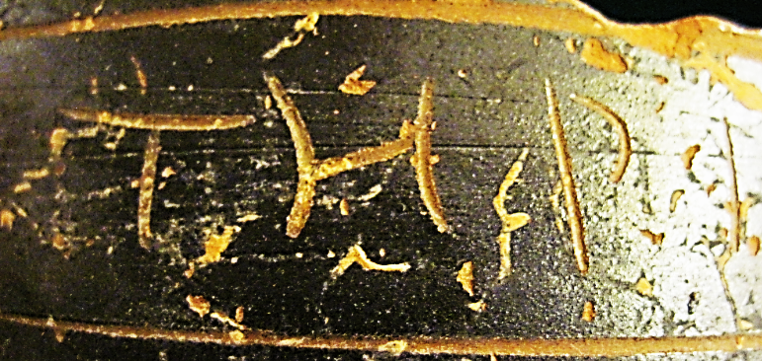 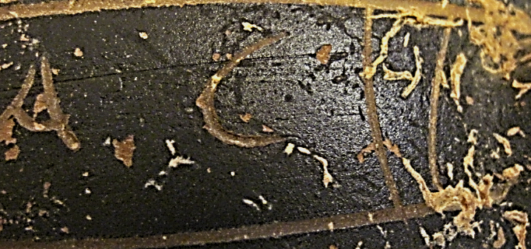

Figs. 1-5.

**Case No.: 4**

**Accession Number: A121**

**Formal Label:** Greece-Attic-Kylix-inscribed-ca 450 BCE

**Display Description:** Κύλιξ, *kylix*, is cognate with the Latin *calix,* and the English "chalice." The kylix was a wine drinking vessel that permitted drinking while recumbent. This particular kylix is inscribed in Greek “||| C       C” = *o‘ Tηρίον= “ o’ wild beast*”= metaphorically, Bacchus*!*

**LC Classification:** NK4645

**Date or Time Horizon:** ca 450 BCE

**Geographical Area: Attica, Greece**

**Map:**

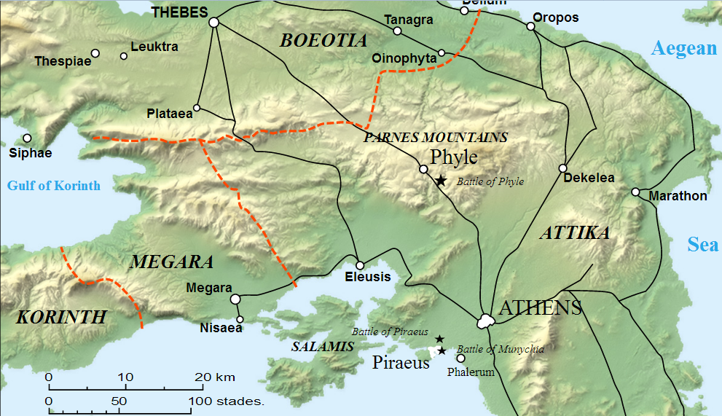

**Fig. 6. Map of Greece showing the location of Attica. From https://upload.wikimedia.org/wikipedia/commons/c/cf/Phyle_map-en.svg**

**GPS Coordinates:** 38º02'44.72" N 23º51'30.51" E

**Cultural Affiliation:** Classical Attica, Greece

**Medium:** ceramic with black slip

**Dimensions**: Dia 117.02 mm, 4.607 in; H 52.26 mm, 2.057in  
**Weight:** 69 g, 2 3/8 oz

**Provenance: Attica**

**Condition:** original

**Discussion:**

Many kylix have satirical aspects of drunkenness associated either with their images or with their inscriptions as in this example.

**References:**

Eberhard, Paul. 1983.*Griechische Vasenmalerei*. Wien: Edition Tusch.

Furtwangler, A. and K. Reichhold. 1902. *Griechische Vasenmalerei: Auswahl hervorragender Vasenbilder / mit Unterstutzung aus dem Thereianos-Fonds der Kgl. Bayerischen Akademie der Wissenschaften herausgegeben von A. Furtwangler und K. Reichhold; nach Furtwanglers tode fortgefuhrt von Friedrich Hauser.* Munchen: Bruckmann.